CMIT 350 WAN and SOHO Skills Implementation

Course: CMIT 350 Interconnecting Cisco Devices (Part 2)
Professor: Rodolfo Solis
Created by: Chris Reagan
Date: 6/23/16

Summary:
- Worchester Subnetting Configurations and Boston Site Protocol, Route Summarization, and Topology Improvements
- Bibliography

I. Worchester Subnetting Configurations and Boston Site Protocol, Route Summarization, and Topology Improvements

Site Details and Challenges

Subnetting Configurations:

Currently, there are a total of four different VLAN’s made up for Faculty, Administrative, Instructional, and Server sites. The Worchester site has a total of 288 devices and there will be a need for growth in the future. The network has already been allocated the 10.20.0.0/16 IP’s which consists of 65,534 hosts in total. To break this down in a really easy way I’ve chosen to subnet the 10.20.0.0/16 network into /24 subnets which will accommodate the largest VLAN, which has 215 hosts. Also, the VLAN’s that only have a few hosts right now this configuration will allow for expansion when the time comes in the future.

Net ID | Usable Range | Subnet Mask | CIDR Value | Broadcast
10.20.0.0 – Faculty VLAN | 10.20.0.1-10.20.0.254 | 255.255.255.0 | /24 | 10.20.0.255
10.20.1.0 – Administrative VLAN | 10.20.1.1-10.20.1.254 | 255.255.255.0 | /24 | 10.20.1.255
10.20.2.0 – Instructional VLAN | 10.20.2.1- 10.20.2.254 | 255.255.255.0 | /24 | 10.20.2.255
10.20.3.0 – Server VLAN | 10.20.3.1-10.20.3.254 | 255.255.255.0 | /24 | 10.20.3.255

Boston Site Protocol, Route Summarization, and Topology Improvements:

Routing Protocol:

OSPF builds a database of routes to its neighbor’s and using Dijkstra’s algorithm, calculates the best possible path. OSPF needs to be aware of the up or down state of its neighbor’s in order to calculate the best path. RIP and RIP-2 are distance vector protocols. RIP uses "number-of-hops" as it’s metric and Bellman-Ford algorithm to calculate the best route based on the number of "hops" it takes to reach the specified subnet.
EIGRP is Cisco proprietary hybrid between link-state and distance vector. EIGRP combines OSPF and RIP to determine the best route for each subnet.

Summarization:

Summarizing IP addresses ensures that there are no entries for child routes, which are routes that are created for any combination of the individual IP addresses contained within a summary address in the routing table. In summary the routing table will be as follows;

- BostonRouter1:
10.10.0.1, 10.10.2.1, 10.10.4.1, 10.10.6.1 10.10.0.0/21
10.10.10.1, 10.10.12.1, 10.10.14.1, 10.10.16.1 10.10.0.0/19
- BostonRouter2:
10.10.0.1, 10.10.2.1, 10.10.4.1, 10.10.6.1 10.10.0.0/21
10.10.10.1, 10.10.12.1, 10.10.14.1, 10.10.16.1 10.10.0.0/19
- BostonRouter3:
10.10.0.1, 10.10.2.1, 10.10.4.1, 10.10.6.1 10.10.0.0/21
10.10.10.1, 10.10.12.1, 10.10.14.1, 10.10.16.1 10.10.0.0/19

Default Route:
- BostonRouter1
10.50.0.0/16 165.128.63.1
10.40.0.0/16 165.128.63.1
10.30.0.0/16 10.255.255.248/30
10.20.0.0/16 10.255.255.248/30
- BostonRouter2
10.50.0.0/16 10.10.255.250
10.40.0.0/16 10.10.255.250
10.30.0.0/16 10.10.255.250
10.20.0.0/16 10.10.255.250
- BostonRouter2
10.50.0.0/16 10.10.255.254
10.40.0.0/16 10.10.255.254
10.30.0.0/16 10.10.255.254
10.20.0.0/16 10.10.255.254

Improvements:

Business Needs:

The organization will need internet at all the times, therefore the internet should be optimum at all times. This calls for contacting three internet providers to do the business with the organization to ensure high speed connections to the internet. Should one provider fail, the two providers will still provide the internet connection.

Proposed Network Services

The network services that will be used in the provision of the internet include

1. Comcast

2. AT&T

3. Time Warner

All the providers will provide 100Mbs internet.

Reasoning

Reliability is essential for the students, and members of the staff to carry out the necessary work they need. The companies will provide the most efficient measures to ensure that the network is well configured. With the experience they have, these companies are very familiar with setting up a configuration like this.

Proposed Network Security Measures:
Security in the hardware is a very important measure in network security. It is therefore very important that security is enhanced. The first measure to be taken is considering a back-up of data. This backup should be put in a different room with a lock and a camera to have surveillance in the perimeter. A firewall will also enhance the defense of the network. The firewall will limit the exposure of the network to threats in the network. The threats include the external attacks and hackers it also mitigates the risks of hacking should an attacker succeed in breaching the security of the network. A VPN is also another security measure that can be used to provide secure connectivity from outside the organization.
Topology Recommendations (Network):

The recommendation is for additional leased lines from the Los Angeles Router to the internet and from the Boston Router to the internet. We can also have additional lines from the San Francisco Router to the internet, from the Springfield Router to the internet, and from the Worchester Router to the internet, as shown by red lines in the picture below.

Los Angeles Router s0/0/2 165.128.63.4/26
Boston Router s0/0/1 165.128.63.5/26
Sacramento Router s0/0/1 10.255.255.253/30
Springfield Router s0/0/1 10.255.255.247/30
Worchester Router s0/0/1 10.255.255.249/30

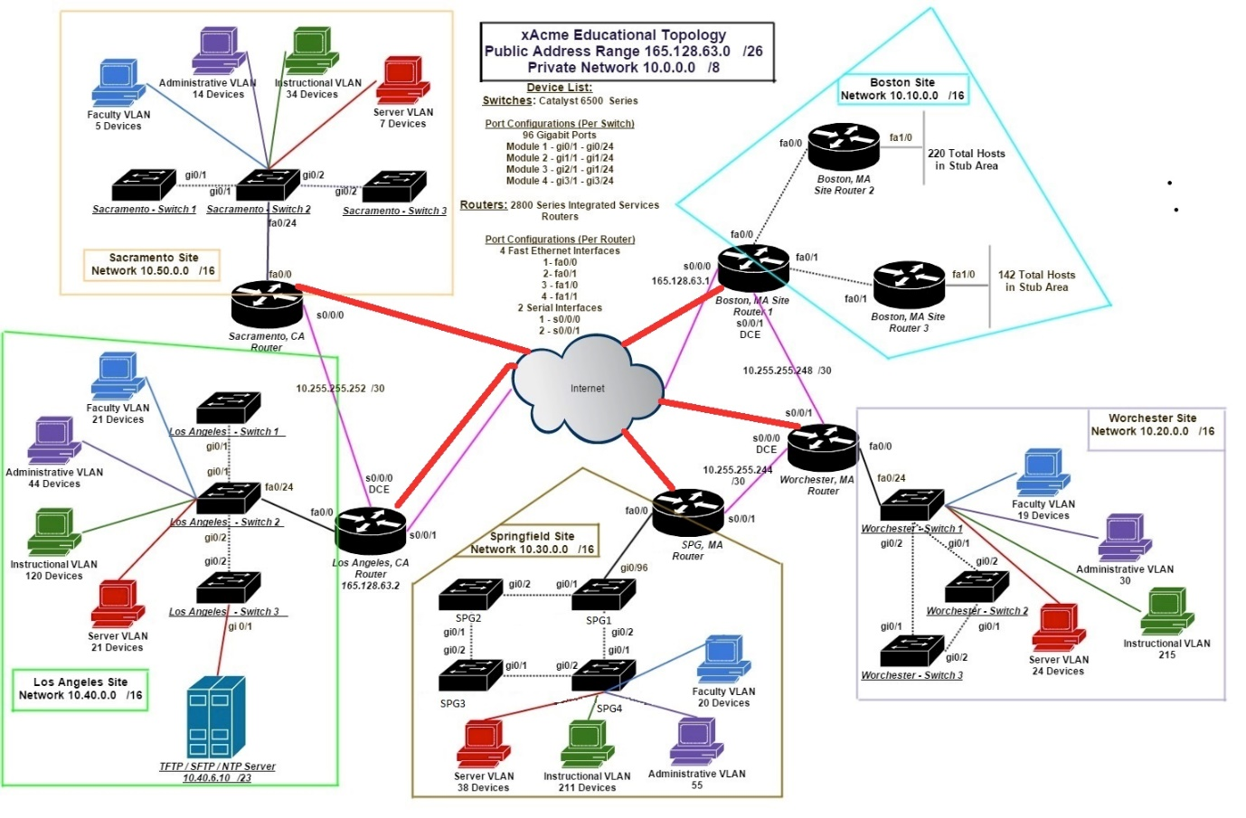

Bibliography

[1]B. Routing Protocol Selection Guide - IGRP, "Routing Protocol Selection Guide - IGRP, EIGRP, OSPF, IS-IS, BGP | LAN, Switching and Routing | Cisco Support Community | 6016 | 127851", Supportforums.cisco.com, 2016. [Online]. Available: https://supportforums.cisco.com/document/127851/routing-protocol-selection-guide-igrp-eigrp-ospf-bgp. [Accessed: 23- Jun- 2016].

[2]D. Teare and C. Paquet, "Route Summarization > CCNP Self-Study: Advanced IP Addressing", Ciscopress.com, 2016. [Online]. Available: http://www.ciscopress.com/articles/article.asp?p=174107&seqNum=3. [Accessed: 23- Jun- 2016].

[3]"Networking 101: Understanding OSPF Routing", Enterprisenetworkingplanet.com, 2016. [Online]. Available: http://www.enterprisenetworkingplanet.com/netsp/article.php/3610496/Networking-101-Understanding-OSPF-Routing.htm. [Accessed: 23- Jun- 2016].

